Is the Fama-French Three Factor Model
Relevant for Asia?

Yimeng Hua, Wencheng Zhang
Advisor: Dr. Michael Aguilar
September 15, 2020
Herbert Brown Mayo Research Fellowship in Financial Economics, Summer 2020

Introduction
Markowitz proposed the Modern Portfolio Theory (MPT) in 1952, and then a variety of models developed to determine portfolio returns with market returns. Among them, Capital Asset Pricing Model (CAPM), which developed by Sharpe (1964), Treynor (1965) and Lintner (1965), is a popular one. CAPM uses only one variable - market factor - to describe the relationship between portfolio returns and market returns. But CAPM has been criticized for its limitation to explain the variations in expected portfolio returns by only the market factor.
In order to capture more cross-sectional variations in average stock returns, Fama and French (1993) added two factors: firm size factor and book-to-market-equity (BE/ME) factor to develop the Fama-French three factor model. The model is for predicting the risk and returns of stocks or portfolios and now it relates the expected portfolio returns to three categorized risk.
The original Fama-French three factor model was established in the U.S. stock market. Fama and French collected return data from New York Stock Exchange (NYSE), American Stock Exchange (AMEX), and NASDAQ to create U.S. portfolios. Later, a number of empirical studies were conducted to test the validity of the model in other regions, including North America, Europe, Asia Pacific and so on. We would like to update the findings for Asia Pacific in the paper.
Our paper focuses on how the Fama-French three factor model performs in Asia Pacific. We propose our question as is the Fama-French three factor model relevant for Asia? We select the following five areas: Hong Kong, Singapore, South Korea, India and China to comprise our Asian Pacific market. Different literature defined Asia emerging market in different ways. Chui and Wei (1998) chose Hong Kong, Korea, Malaysia, Taiwan, and Thailand as five Pacific-Basing emerging markets from 1977 to 1993. For our research, we are going to use Hong Kong, South Korean, Singapore, India, and China Mainland to define the Asia emerging market from July 2005 to December 2012. Even though there are different standards to define the emerging market, this paper uses total market capitalization and total value of stocks traded as two criteria. Figure 1 and Figure 2 display the overall movement of different emerging markets from 2005 to 2012.
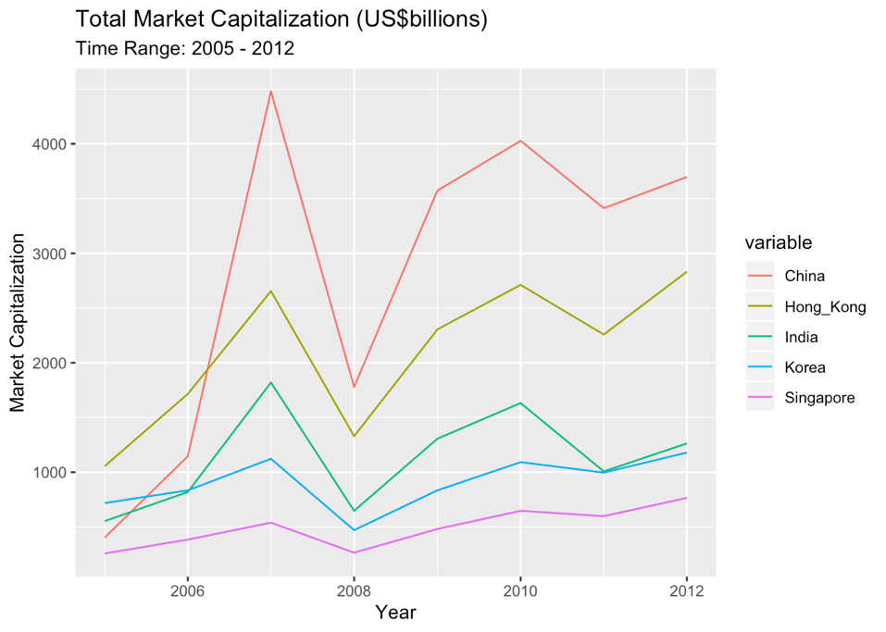
Figure 1: Total Market Capitalization (US$billions)

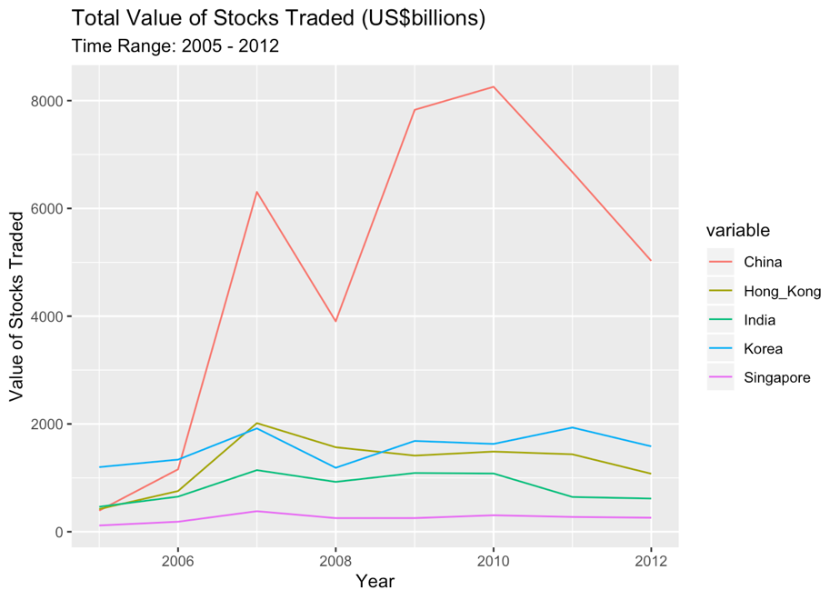
Figure 2: Total Value of Stocks Traded (US$billions)

In order to check the validity of Fama-French three factor model, we would like to analyze in three steps: 1) Check the returns 2) Check the factors 3) Check the coefficient betas. Our investigation divides into three phases by the above three key elements of the model and therefore to compare universe returns, factors and betas among different countries and to check the validity of the three-factor model in Asian market.

Literature Review
After Markowitz proposed the Modern Portfolio Theory (MPT) in 1952, a variety of models have been developed to determine portfolio returns with market returns. Among them, Capital Asset Pricing Model (CAPM), which developed by Sharpe (1964), Treynor (1965) and Lintner (1965), is a popular one. CAPM uses only one variable—market factor, the return expected from the market above the risk-free rate– to describe the relationship between portfolio returns and market returns. The coefficient of the market risk premium, which is a key variable in CAPM, is called beta. It is calculated by dividing the product of the covariance of the security’s returns and the market’s returns by the variance of the market’s returns to measure the portfolio’s volatility to market risk. However, CAPM has been criticized for its limitation to explain the variations in expected portfolio returns by only the market factor.
Fama and French (1992) found out that on average, 70% of the portfolio returns can be explained by its beta and the other 30% is explained by other variables not related to beta. They studied the combined effect of beta, size, leverage, book-to-market equity, and earnings-price ratios and realized two variables size and book-to-market equity were significant to capture the cross-sectional variations in average stock returns. Fama and French (1993) added two other factors: firm size factor and book-to-market-equity (BE/ME) factor to develop the Fama-French three factor model. The model helps to improve the explanatory power of CAPM by two additional value factors. It is for predicting the risk and returns of stocks or portfolios and now it relates the expected portfolio returns to three categorized risk. In particular, they found a negative relationship between returns and size and a positive relationship between returns and book-to-market-equity value. In 1995, Fama and French further studied how size and book-to-market-equity describes the earning behavior. They found that the high ratio of book equity to market equity (BE/ME) signals poor earnings; comparatively, low BE/ME shows strong earnings.
The Fama-French three factor model was originally established in the U.S. stock market. Later, a number of empirical studies were conducted to test the validity of the model in other regions, including North America, Europe, Asia Pacific and so on. In 1998, Chui and Wei investigated five Pacific-Basin emerging markets to see the book-to-market equity can explain the cross-sectional variation of expected stock returns as well as the size effect is significant. Also, they found that the degree of correlation between average stock returns and the BE/ME ratio within a country is closely related to the average BE/ME ratio of that country. In 2015, Fama and French made an international test of a five-factor asset pricing model, which covers the areas including 1) North America, 2) Japan, 3) Asia Pacific and 4) Europe. The five-factor model adds profitability and investment factors to the three-factor model. The test result shows that the average stock returns are positively related to BE/ME and profitability while negatively related to investment.

Methodology
The original CAPM is represented as:
E (Ri ) = Rf + βi (E(Rm) - Rf ))
Here Rf is the risk-free rate and βi is the beta of the investment. E(Rm)-Rf is the expected excess return of the market portfolio beyond the risk-free rate, usually known as market risk premium.
To capture the anomalies of CAPM, the Fama-French three factor model adds two risk factors: size risk and value risk on the original model, representing the market capitalization (“size”) and BE/ME ratio (“value”) returns. Now, the excess portfolio return relates to three factors: 1) E(Rm)-Rf market risk premium factor; 2) “Small Minus Big” market capitalization risk factor; and 3) “High Minus Low” value premium risk factor. The Fama-French three factor model is shown as:
E (Ri ) = Rf + βi (E(Rm) - Rf ) + si SMB + hi HML)
Here SMB, small minus big, is the difference between the excess return on a portfolio of small stocks and that on a portfolio of big stocks. The additional return is marked as the “size premium”. HML, high minus low, is the difference between the excess return on a portfolio of high-book-to-market stocks and that on a portfolio of low-book-to-market stocks. Companies with high book-to-market values are known as value stocks and companies with low book-to-market values are signaled as growth stocks. HML which accounts for the spread in returns between value stocks and growth stocks is known as the “value premium” to suggest investors that value stocks usually outperform growth stocks. The Fama-French three factor model allows investors to weight their portfolios so that each of the risk factor will have larger or lesser exposure to achieve different levels of expected returns.
Fama and French constructed six size and value sorted portfolios (Small Value, Small Neutral, Small Growth, Big Value, Big Neutral, Big Growth) and applied excess market returns proxy to mimic the stock return behavior. SMB and HML factors are constructed using the six value-weight portfolios formed on size and book-to-market. SMB is the average return on the three small portfolios minus the average return on the three big portfolios, which is calculated as:
SMB = 1/3 (Small Value + Small Neutral + Small Growth) - 1/3 (Big Value + Big Neutral + Big Growth).
HML is the average return on the two value portfolios minus the average return on the two growth portfolios, which is calculated as:
HML = 1/2 (Small Value + Big Value) - 1/2 (Small Growth + Big Growth)
In our paper, we cited Fama-French factors and portfolios in five Asian Pacific markets from Stefano Marmi’s data library. This data library constructed the Fama-French factors with the same way as Fama and French did. To be more specific, the portfolios created by this data library are constructed at the end of each June. ME is market capitalization at the last fiscal year end before June. BE/ME is book equity at the last fiscal year end before March divided by ME at the last fiscal year end before June.

Exploratory Data Analysis

We will utilize current and historical returns data of Fama-French three factors (MRF, SMB, and HML) and portfolios in Hong Kong, Singapore, South Korea, India, and China Mainland, provided by Stefano Marmi’s data library. The data library provides time-series data until March 2013, while the start dates for different areas are not the same, which varies from July 1988 to July 1998. We decide to investigate all areas from July 2005 to December 2012 because of three reasons. First, the sample period should be relatively recent to guarantee the consistency and stability of time series data. Second, there are more than 65% of non-tradable stocks before 2005 in China’s stock market. Non-tradable stocks will have an unexpected and unreasonable effect from tradable stocks, which oversimplifies the whole situation. Thus, the earliest time of the sample period will be Jan 2005. The last reason is that the sample period has a timespan of 96 months over eight years, which is relatively stable and effective in conducting the empirical analysis. Also, the data library uses different risk-free rates based on different areas in Tables 1 (Hong Kong: Hong Kong 3 months deposit rate; Singapore: Singapore 3 months Treasury bill rate; South Korea: South Korea 91 days rate; India: India 91 days Treasury bill rate; China: China 91 days Treasury bill rate). We will follow the same standard along with the empirical analysis.

Table 1: Sampling periods and the risk-free rates for the empirical analysis
Country | Sampling period | Risk-free rate
China | 01/2000 -- 12/2012 | China 91 days Treasury bill rate
India | 01/2000 -- 12/2012 | India 91 days Treasury bill rate
South Korea | 01/2000 -- 12/2012 | South Korea 91 days rate
Hong Kong | 01/2000 -- 12/2012 | Hong Kong 3 months deposit rate
Singapore | 01/2000 -- 12/2012 | Singapore 3 months Treasury bill rate

From Table 2 to Table 6, it represents the summary statistics of the monthly average return and the market factor Rm-Rf, the size factor SMB, and the value factor HML from 2005 to 2012. These tables display that except for China, average excess returns are positively related to book to market value (HML) for the rest of emerging markets. Besides, the average excess return is positively related to the size factor (SMB) for all of the emerging markets. We also notice that the standard deviation of average excess returns does not vary a lot across different countries. China’s stock market has the highest standard variation, and next in order are India, Hong Kong, Singapore, and South Korea. The highest standard deviation demonstrates that China is the most volatile market among these five countries. Singapore and South Korea is the most stable market compared to others.
Table 2: Descriptive statistics of independent variables and the monthly returns
China | Returns | HML | SMB | Rm_Rf
Mean | 1.901041667 | -0.093541667 | 0.709375 | 1.709583333
Standard Error | 1.044806606 | 0.316364768 | 0.47683144 | 1.046079312
Median | 2.005 | -0.01 | 0.785 | 1.83
Mode | 4.8 | -0.16 | 3.16 | -0.12
Standard Deviation | 10.23697226 | 3.099729013 | 4.67197486 | 10.24944218
Sample Variance | 104.795601 | 9.608319956 | 21.8273491 | 105.0510651
Kurtosis | 0.268205261 | 0.19597301 | 0.01154939 | 0.264082707
Skewness | -0.108680676 | 0.186054425 | -0.3510053 | -0.112427192
Range | 54.84 | 14.96 | 22.45 | 54.8
Minimum | -26.83 | -6.98 | -12.29 | -27.07
Maximum | 28.01 | 7.98 | 10.16 | 27.73
Sum | 182.5 | -8.98 | 68.1 | 164.12
Count | 96 | 96 | 96 | 96
Confidence Level(95.0%) | 2.074203363 | 0.628063472 | 0.94663009 | 2.076730005

Table 3: Descriptive statistics of independent variables and the monthly returns
India | Returns | HML | SMB | Rm-Rf
Mean | 1.584583333 | 0.077604167 | 0.52989583 | 1.0565625
Standard Error | 0.911490188 | 0.369064807 | 0.51057004 | 0.91527989
Median | 1.585 | -0.43 | -0.035 | 1.115
Mode | 0.5 | -0.44 | 5.99 | #N/A
Standard Deviation | 8.930743461 | 3.616081841 | 5.0025443 | 8.967874809
Sample Variance | 79.75817877 | 13.07604788 | 25.0254495 | 80.42277859
Kurtosis | 4.912954503 | 0.93789715 | 2.18473214 | 4.949891562
Skewness | 0.450713448 | 0.697475777 | 0.8585207 | 0.458149282
Range | 71.87 | 20.23 | 28.62 | 72.21
Minimum | -29.32 | -8.3 | -8.25 | -29.93
Maximum | 42.55 | 11.93 | 20.37 | 42.28
Sum | 152.12 | 7.45 | 50.87 | 101.43
Count | 96 | 96 | 96 | 96
Confidence Level(95.0%) | 1.80953681 | 0.732686279 | 1.01360968 | 1.81706032

Table 4: Descriptive statistics of independent variables and the monthly returns
South Korea | Returns | HML | SMB | Rm_Rf
Mean | 1.087083333 | 1.123541667 | 0.85427083 | 0.7721875
Standard Error | 0.64507974 | 0.398850568 | 0.46823853 | 0.647377642
Median | 1.16 | 0.84 | 0.295 | 0.94
Mode | 8.25 | 3.64 | -1.9 | 1.99
Standard Deviation | 6.320464826 | 3.907921504 | 4.58778188 | 6.342979576
Sample Variance | 39.94827561 | 15.27185048 | 21.0477426 | 40.2333899
Kurtosis | 2.571117174 | 0.771305984 | 1.13829012 | 2.624230763
Skewness | -0.646982799 | 0.129300782 | 0.75720599 | -0.652561089
Range | 42.34 | 21.72 | 24.96 | 42.63
Minimum | -25.81 | -10.07 | -6.98 | -26.3
Maximum | 16.53 | 11.65 | 17.98 | 16.33
Sum | 104.36 | 107.86 | 82.01 | 74.13
Count | 96 | 96 | 96 | 96
Confidence Level(95.0%) | 1.280645201 | 0.791818491 | 0.92957101 | 1.285207114

Table 5: Descriptive statistics of independent variables and the monthly returns
Hong Kong | Returns | HML | SMB | Rm_Rf
Mean | 1.498020833 | 0.4775 | 0.0478125 | 1.421354167
Standard Error | 0.797386997 | 0.318823014 | 0.5864396 | 0.796335516
Median | 2.2 | 0.705 | -0.585 | 2.09
Mode | 3.36 | 1.21 | -2.06 | -1.87
Standard Deviation | 7.812765077 | 3.123814807 | 5.74591117 | 7.802462718
Sample Variance | 61.03929815 | 9.758218947 | 33.0154952 | 60.87842446
Kurtosis | 1.561797962 | -0.089201362 | 2.14884088 | 1.577155493
Skewness | -0.557711882 | -0.188911675 | 0.84334425 | -0.554714066
Range | 46.25 | 15.61 | 32.73 | 46.3
Minimum | -24.95 | -7.79 | -12.02 | -25.01
Maximum | 21.3 | 7.82 | 20.71 | 21.29
Sum | 143.81 | 45.84 | 4.59 | 136.45
Count | 96 | 96 | 96 | 96
Confidence Level(95.0%) | 1.583013335 | 0.632943708 | 1.16422981 | 1.580925883

Table 6: Descriptive statistics of independent variables and the monthly returns
Singapore | Returns | HML | SMB | Rm_Rf
Mean | 1.0396875 | 0.683020833 | 0.17666667 | 0.94125
Standard Error | 0.658226109 | 0.221495471 | 0.42906832 | 0.65823665
Median | 1.895 | 0.52 | -0.345 | 1.795
Mode | 4.51 | 0.47 | 0.79 | 2.85
Standard Deviation | 6.449272412 | 2.170203541 | 4.20399376 | 6.449375694
Sample Variance | 41.59311464 | 4.70978341 | 17.6735635 | 41.59444684
Kurtosis | 6.509034754 | 1.283061966 | 5.2761953 | 6.583655182
Skewness | -0.094373429 | 0.139797693 | 1.47389463 | -0.084903964
Range | 55.25 | 13.08 | 30.06 | 55.37
Minimum | -25.61 | -4.75 | -11.11 | -25.75
Maximum | 29.64 | 8.33 | 18.95 | 29.62
Sum | 99.81 | 65.57 | 16.96 | 90.36
Count | 96 | 96 | 96 | 96
Confidence Level(95.0%) | 1.306744044 | 0.439724107 | 0.85180831 | 1.306764971

One disadvantage of the Stefano Marmi’s data library is the lack of details and explanation of individual portfolios structure. In other words, even though there is the excess return on the market portfolio, size premium, value premium and returns for each month in the country’s level, a specific value of stocks and portfolios in the company’s level is lacking, which violates assumptions of Fama and French three-factor model. To solve this problem, we weighted the value of individual returns for each country by multiplying the annual market capitalization ratio. Table 7 display a summary of the market ratio for each country from 2005 to 2012. By doing so, this method improves the returns in the company’s level to Asia’s level, which allow us to conduct the empirical analysis of Fama and French three-factor model
Table 7: Annual market capitalization ratio for each country
Year | China | India | Singapore | Hong Kong | South Korea
2005 | 13.46% | 18.53% | 8.62% | 35.34% | 24.05%
2006 | 23.39% | 16.72% | 7.85% | 35.01% | 17.04%
2007 | 42.20% | 17.14% | 5.08% | 25.01% | 10.58%
2008 | 39.61% | 14.41% | 5.90% | 29.59% | 10.48%
2009 | 42.03% | 15.37% | 5.66% | 27.12% | 9.82%
2010 | 39.84% | 16.14% | 6.40% | 26.82% | 10.80%
2011 | 41.25% | 12.18% | 7.23% | 27.30% | 12.04%
2012 | 37.97% | 12.97% | 7.86% | 29.08% | 12.11%

Empirical Results

We answer the question “is the Fama-French three factor model relevant for Asia?” in three steps: returns, factors and coefficient betas.
In the general overview (Table 8-12), R-squared values of the Fama-French three factor models for each of the five areas are absolutely high, ranging from 87.64 percent to 99.17 percent. The R-squared of the five regressions have an average value of 95.94 percent, implying that the Fama-French three factor model indeed explain cross-sectional variations in portfolio returns. We can also see the explanatory power of the three-factor model from the regression intercept. Theoretically, the intercepts of the time series regressions will tend to zero if the model can satisfactorily explain changes in expected returns. Seen from Figure 3, the intercept values vary from -0.0279 to 0.3818. The values of intercepts for Singapore, Hong Kong and South Korea are relatively low, -0.0279, 0.0694 and 0.2577 separately. Also, the t-statistics are insignificant for these three areas, showing that the three factors model does reflect the most variations in returns. Comparatively, the intercept values for China and India are 0.3818 and 0.3024 correspondingly and are significant at the 1 percent level.

Table 8: Regression Result for China
China: 2005 - 2012
Adjusted R-squared: 0.9559
Value Std. Error t value Pr(>|t|)
(Intercept) 0.38178 0.21595 1.768 0.0804 .
Book to market -0.04618 0.17309 -0.267 0.7902
Size -0.12172 0.12737 -0.956 0.3417
Beta 2.54027 0.05492 46.256 <2e-16 ***

Table 9: Regression Result for India
India: 2005 - 2012
Adjusted R-squared: 0.9912
Value Std. Error t value Pr(>|t|)
(Intercept) 0.30239 0.08717 3.469 0.000797 ***
Book to market 0.33768 0.16594 2.035 0.044730 *
Size -0.21685 0.10878 -1.993 0.049170 *
Beta 6.47340 0.06750 95.902 < 2e-16 ***

Table 10: Regression Result for South Korea
South Korea: 2005 - 2012
Adjusted R-squared: 0.8764
Value Std. Error t value Pr(>|t|)
(Intercept) 0.2577 0.2429 1.061 0.29145
Book to market 0.1209 0.3789 0.319 0.75046
Size -0.8913 0.3176 -2.807 0.00611 **
Beta 6.8854 0.2695 25.546 < 2e-16 ***

Table 11: Regression Result for Singapore
Singapore: 2005 - 2012
Adjusted R-squared: 0.9818
Value Std. Error t value Pr(>|t|)
(Intercept) -0.02792 0.09504 -0.294 0.770
Book to market 0.45539 0.63037 0.722 0.472
Size 0.47900 0.35222 1.360 0.177
Beta 16.02197 0.22883 70.016 <2e-16 ***

Table 12: Regression Result for Hong Kong
Hong Kong: 2005 - 2012
Adjusted R-squared: 0.9917
Value Std. Error t value Pr(>|t|)
(Intercept) 0.06943 0.07445 0.933 0.353
Book to market -0.12037 0.08245 -1.460 0.148
Size 0.07544 0.04676 1.613 0.110
Beta 3.49280 0.03314 105.408 <2e-16 ***

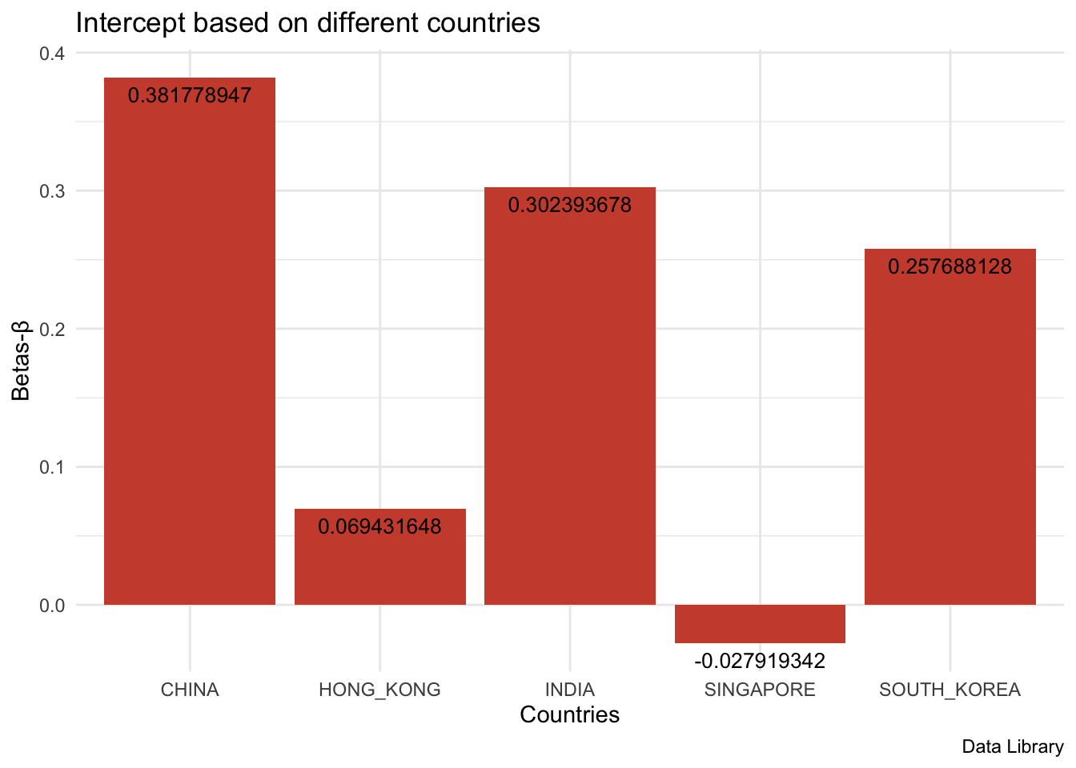
Figure 3: Intercept based on different countries

For the first phase, India, South Korea, Hong Kong and Singapore hold the similar tendency for time series return data (Figure 4 to Figure 8): the market performances are relatively stable except the 2008 Great Depression. All five markets bounce off starting from the middle of 2009. The correlation analysis (Table 13) shows China has weak correlations (<0.5) with all other four areas. China, the one with the largest market capitalization, holds the highest average returns. India and South Korea follow behind, matching the order of market capitalization for these countries. At the meantime, China, India, and Hong Kong have higher volatility compared with South Korea and Singapore, which two are considered to behave more like developed market.

Figure 4: Time series Return data in China

Figure 5: Time series Return data in India

Figure 6: Time series Return data in South Korea

Figure 7: Time series Return data in Hong Kong

Figure 8: Time series Return data in Singapore
 | China | India | South Korea | Hong Kong | Singapore
China | 1
India | 0.3329 | 1
South Korea | 0.3659 | 0.6543 | 1
Hong Kong | 0.4625 | 0.7526 | 0.6903 | 1
Singapore | 0.3889 | 0.8294 | 0.7251 | 0.8246 | 1

Table 13: Correlation Analysis in Return

Secondly, we move to compare and contrast three factors (market risk premium, small minus big, high minus low). Market risk premium is the difference between the expected return of the market and the risk-free rate. Therefore, it holds a similar tendency with the universe returns we analyze in the first phase. Market risk premium provides an investor with an excess return as compensation for the additional volatility of returns over and above the risk-free rate. Small minus big measures the historic excess of small-cap companies over big-cap companies. Figure 9 indicates that South Korea, China, and India hold relatively higher mean values for SMB. High minus low accounts for the spread in returns between companies with a high book-to-market value ratio (value companies) and companies with a low book-to-market value ratio (growth companies). In Figure 10, it is clear to show that all countries except China have positive average HML values.

Figure 9: average SMB based on different countries

Figure 10: average HML based on different countries

For the third phase, we analyze the exposures to these factors. In order to apply the Fama-French three factor model, we rescale all factors to the Asian market level by multiplying the market capitalization weight. For the market risk premium, all betas are statistically significant and much higher than 1, indicating each country’s market is more volatile than the Asian market as a whole. Among them, Singapore is the most volatile one. For the size effect factor, Hong Kong and Singapore have positive exposure. Although the beta value is much lower than 1, this still explains the portfolios’ returns are attributable to the SMB factor while these two countries’ portfolios don't move as dramatically as when the overall market moves. For China, India and South Korea, the coefficients are negative, showing the portfolios are negatively correlated to the size effect factor. These countries comprise almost all of the companies with large capitalization markets. For the value premium, India, Singapore, and South Korea have positive coefficients. Their excess returns can partly attribute to the value premium. China and Hong Kong take the negative values. Their portfolios are more composed of growth companies. It is noticeable that Singapore shows positive values for SMB and HML factor while China holds both negative values. Their stock compositions are greatly different.

Conclusion
This paper investigates the relationship between expected stock returns and three factors (market risk premium, small minus big, high minus low) in five emerging Asian markets, namely China, Hong Kong, South Korea, Singapore, and India. The overall findings of the research show that it is noteworthy and efficient to construct a profitable investment strategy by using Fama-French three factor model. The possible outcomes driven by Fama-French three factor model will be better than Capital Asset Pricing Model that only focuses on one factor. In other words, the Fama-French three factor model is an improvement over the CAPM to explain the return behavior in emerging Asian markets. This is meaningful for investors who want to invest stock market in Asia market because it will give them a better tool to evaluate the portfolio performance and help them make a profitable decision. More specifically, we find evidence to support that Fama-French three factor model indeed explains cross-sectional variations in portfolio returns for each of the five areas. South Korea, China, and India hold relatively higher mean values for SMB (Small minus Big). Besides, the result shows that all countries except China have positive average HML values (High minus Low). In order to solve one problem of the original dataset, we rescale all factors to the Asian market level by multiplying the market capitalization weight. After conducting the interaction regression model, we found that each country’s market is more volatile than the Asian market as a whole, and Hong Kong and Singapore have positive exposure for the size effect. The portfolios are negatively correlated to the size effect factor for China, India and South Korea.
We have limited time series return data ranging from January 2005 to December 2012. We suggest for the further research, it is helpful to create size and value sorted portfolios using updated data for selected companies. With the up-to-date data, further steps can be done to check the validity of Fama-French three factor model in today’s Asian market and see how it varies over time.

Acknowledgement
We deeply appreciate the opportunity to work on the summer research project sponsored by the Herbert Brown Mayo Summer Research Fellowship from UNC Economics Department. We would like to thank our advisor, Prof. Mike Aguilar, for his mentorship and guidance. From brainstorming the potential research topics to constructing the empirical model, this research project would not have been made possible without his immensurable amount of support.

References
Chui, A. C. W., and K. C. J. Wei, (1998), “Book-to-market, firm size and the turn-of-the year effect: Evidence from Pacific Basin emerging markets,” Pacific Basin Finance Journal 6:275–93.
Chander, Ramesh and Mehta, Kiran, (2010), “Application of Fama and French Three Factor Model and Stock Return Behavior in Indian Capital Market,” Asia-Pacific Business Review Vol. VI, No. 4
Fama, F. Eugene and French R. Kenneth, (1992), “The Cross-Section of Expected Stock Returns,” Journal of Finance, Vol. 47, pp. 427-465.
Fama, F. Eugene and French R. Kenneth, (1993), “Common Risk Factors in the Returns on Stocks and Bonds,” Journal of Financial Economics, Vol. 33, pp. 3-65.
Fama, F. Eugene and French R. Kenneth, (1995), “Size and Book-to-Market Factors in Earnings and Returns,” Journal of Finance, Vol. 50, pp. 131-155.
Fama, F. Eugene and French R. Kenneth, (2015), “A five-factor asset pricing model,” Journal of Financial Economics 116:1–22.
Lintner, J. (1965), “The valuation of risk assets and the selection of risky investments in stock portfolios and capital budgets. Review of Economics and Statistics,” 47(1), 12-37.
Markowitz, H. (1952). “Portfolio selection,” The Journal of Finance, 7(1), 77-91.
Marmi, Stefano. “The Quantitative Portfolio Selection Data.” Stefano Marmi - Data Library, 2012, http://homepage.sns.it/marmi/Data_Library.html
Sharpe, W.F., (1964), “Capital asset prices: a theory of market equilibrium under conditions of risk,” J. Finance 19, 425–442.
Qu, Qiuying and Xie, Shiqing, (2016), “The Three-Factor Model and Size and Value Premiums in China’s Stock Market,” Emerging Markets Finance & Trade, 52:1092–1105.

