Market Structure in the Subscription Video on Demand Industry
Nico Rotundo
The University of North Carolina at Chapel Hill
September 2020

Abstract
The relatively recent widespread adoption of the internet has allowed for the creation of various markets that exist predominantly online. Additionally, this occurrence provides a unique opportunity for modern economic analysis; it allows for the observation of incipient markets developing in real-time with widely available data. The global subscription video on demand (SVoD) industry exists as one of these markets and has previously been unexplored in the context of market structure. This paper seeks to determine how market structure in the SVoD industry has varied through time. Through exploring this question and its implications, the project will further the understanding of the manner in which the characteristics of market structure typically seen in physically-based markets and other online markets manifest in this type of digital space. Furthermore, the project will contribute to the determination of the type of market that best describes the current state of the subscription video-on-demand industry and explicitly suggest how this classification may change going forward, topics which have not been thoroughly explored in prior academic literature.

Introduction
Formally defined, the subscription video on demand (SVoD) industry, also termed the video streaming industry, refers to the collection of services that charge users a monthly subscription fee for unlimited streaming of content housed on their platforms (Statista, 2020). Notwithstanding the failure of a Hong-Kong streaming service in 1998 (Smith, 2017), the first significant entrant into the SVoD industry was Netflix in 2007, when the company launched its online video streaming platform (Hosch, 2020). Since then, the industry has experienced tremendous growth, reporting a projected revenue of US $12.5 billion in 2020 and various new platforms offering this type of service (Statista, 2020). Additionally, growth is expected to continue with 2024 registering revenue projections of US $13.5 billion (Statista, 2020). With the percent of United States households who have eliminated cable in favor of these types of video streaming platforms hovering at 19.9% in 2020 (NoCable, 2020) and the number of households consuming content through traditional and online services expected to be virtually equivalent by 2024 (eMarketer, 2020), an exploration of the market structure of this industry is timely. However, the market structure of the SVoD industry as a topic has been overlooked in previous discussions of the video streaming industry and the market structure of online industries in general. The goal of this paper is to determine how market structure in the subscription video-on-demand market has varied through time, while also suggesting how this classification of the industry may change going forward. Moreover, exploration of this topic will further the understanding of the manner in which the characteristics of market structure typically seen in physically-based markets and other online markets manifest in this type of digital space.
Before transitioning into the topic, I believe an outline will be useful for delineating the progression of the paper. First, I will explore factors that determine the market structure of online markets in general. Then, I will discuss how these factors may manifest in the SVoD market specifically. Following this discussion, I will present the standard methods of quantitatively measuring market structure, convey how the data in this paper is collected, and express the limitations of these data. A discussion of the data and its implications will follow, with a conclusion functioning to demonstrate further limitations of this paper.
Market Structure in Online Markets
While the market structure of the subscription video on demand (SVoD) industry has not yet been significantly explored, the composition and dynamics of other online markets partially illuminate factors that affect the development of market structure in the SVoD market. Additionally, the literature on other internet markets assists in identifying characteristics related to the structure of traditional, non-internet-based markets that may manifest in the SVoD industry. When considering the notion of market structure and the differences between the various types, two central features surface as defining qualities: the degree of product differentiation and the number of firms in the market (Besanko & Braeutigam, 2014). The following paragraphs discuss the factors of these two features of market structure that are relevant to an analysis of the SVoD market.
Product Differentiation
The first defining quality of market structure is the degree of product differentiation. Product differentiation is defined as a scenario in which, from the perspective of the consumer, the characteristics of individual products possess a sufficient degree of difference as to set them apart from one another, rendering them as less than perfect substitutes (Besanko & Braeutigam, 2014). Product differentiation provides individual firms with a method by which they can establish market power (Holcombe, 2009), which functions to increase concentration in regard to market share. There are two distinct types of product differentiation: vertical differentiation and horizontal differentiation (Besanko & Braeutigam, 2014). Vertical differentiation refers to a situation in which all consumers can objectively categorize the individual elements in a set of products as superior or inferior to the other products in the set (Besanko & Braeutigam, 2014). For example, among the population of consumers who desire a phone that can take the best quality pictures possible, the latest iPhone is unambiguously superior to a 2000s era flip phone, which is unambiguously superior to the camera-less brick phones of the 1990s. The counterpart to vertical differentiation is horizontal differentiation. Horizontal product differentiation refers to a situation in which the individual elements in a set of products are different, but this difference cannot be objectively categorized using measures of clear superiority or inferiority (Besanko & Braeutigam, 2014). For example, deciding between two different colors of the same car is a matter of individual consumer preference and not objectivity. Thus, horizontal differentiation is inherently subjective.
Product differentiation has been explicitly suggested by previous literature to possess a degree of influence in determining the market structure of online markets, which primarily derives from the presence of low search costs that is afforded by the internet. Barr-Issac, Caruana, and Cunat (2012) identify a causal link between high vertical product differentiation, in conjunction with the low search costs that are characteristic of online markets in general, and greater price competition, which can function as a proxy measure in determining market structure. Additionally, Dewan, Jing, and Seidmann (2003) indicate that horizontal product differentiation, the capabilities of which they determine are stronger on the internet due to an extraordinary capacity for data collection and customization the medium presents to firms, allows incumbent firms to establish barriers to entry over entrant firms, which can affect market structure. In regard to product differentiation in general, Brynjolfsson, Hu, and Simester (2011) demonstrate that the sale distribution of products on the internet is less concentrated than in previous assessments of offline markets, suggesting a wider variety of products are not only available but also purchased. This phenomenon contrasts a market with a narrow sales distribution where a smaller selection of a few products may be purchased more frequently by consumers. They conclude that this feature of online markets derives partially from low search costs. As such, low search costs allow for the presence of more niche products in the market, which contribute to a greater degree of product differentiation than would be present with higher search costs.
Two interconnected features of online markets that affect vertical product differentiation specifically are both the presence of disruptive innovations and the modular nature of most online products. Evans (2017) indicates that disruptive innovations, which refer to innovations that alter the composition of markets, tend to occur frequently in online markets. Disruptive innovations partially derive from the modular nature of most online products, where modular refers to a design that is composed of smaller, interacting parts that can be independently altered, replaced, or exchanged. This feature has been found to facilitate innovation, as various parts of a modular product can be refined and altered without necessitating an entire redesign (Manuant, 2002). For example, Amazon can improve its product recommendation algorithm without entirely redesigning the infrastructure of its e-commerce service. Levin (2011) confirms that internet platforms experience rapid innovation, which they partially associate with the modular nature of internet products. Owners of software, apps, and subscribers of streaming services alike can receive updates after they have purchased the products, features of digital products that starkly transcend the capabilities of their physical counterparts. This feature of modularity also contributes to the degree of vertical product differentiation in this space, which can theoretically increase more readily with frequent innovation as firms can improve their products more frequently. Furthermore, if the likelihood of innovation occurring in a particular market is higher than average, then the probability of an innovation that is particularly disruptive presenting itself also increases.
Another factor that affects the overall nature of product differentiation in online markets is the capacity for customization of products. Consider a scenario where Dell is competing against Apple in a two-firm computer market. If each firm sells a single variant of a computer, there are two options for consumers to purchase. However, if they each allow for a selection of two colors and two operating systems that differ in performance, there are now eight variants, with a greater degree of vertical differentiation deriving from the choice of operating systems and with a greater degree of horizontal differentiation deriving from the colors of the computers. It is widely accepted that the internet as a transaction medium allows for an unparalleled ability for firms to capture data on the interests and desires of potential consumers in addition to enhancing the capacity of firms to implement customization to tailor products to these interests and desires (Bernhardt, Liu, & Serfes, 2007; see also Dewan, Jing, & Seidmann, 2003; Loginova & Wang, 2011). Consequently, it can be reasonably hypothesized that since the internet facilitates a large capacity for customization, online markets on average experience a higher degree of product differentiation both vertically and horizontally than other markets.
Number of Firms
The second defining quality of market structure is the number of firms present in a market. The individual firms in a market with many firms will record a lesser market share than the firms in a market with a small number of firms, all else equal. Thus, markets with many firms are typically more competitive in this respect than markets with a small number of firms. In regard to the number of firms, monopoly markets, referring to those that inhabit the extreme of the most concentrated market share, primarily arise through the presence of circumstances that potentiate the formation of a natural monopoly or the presence of strong barriers to entry (Besanko & Braeutigam, 2014). The latter of these two conditions for monopoly markets will be most relevant for the purposes of this paper. Given that barriers to entry affect the concentration of market share and do not explicitly fall under the factor of market share, it follows from theory that barriers to entry are a central determinant to the number of firms operating in a market. There are three types of barriers to entry: structural, legal, and strategic.
Structural barriers to entry refer to those that provide an entrant firm a relative cost or demand disadvantage compared to an incumbent firm (Besanko & Braeutigam, 2014), and both cost-derived and demand-derived structural barriers to entry have been demonstrated to affect the market structure of online markets. A central topic in the discussion of demand-advantage structural barriers to entry in online markets is positive network externalities, where positive network externalities, or alternatively network effects, refer to the increased value a product or platform accrues as more people use it (Besanko & Braeutigam, 2014). Positive network externalities are traditionally understood to generate value in an increasing manner, thus being amplified as the number of users increases. Consequently, it is expected that firms holding the greatest market share in a specific industry would benefit most from this effect and would be provided a demand advantage relative to entrant firms. However, Evans (2017) makes the observation that positive network externalities tend to be less of a benefit to leading firms (in regard to their market share) operating primarily in online space compared to entrant firms or firms in offline spaces. This characteristic of weaker positive network externalities experienced by leading firms in online space partially derives from the ability of users of online platforms to switch between the products of firms at a low cost (Evans, 2017). Consumers of online products can often access multiple platforms and products without any secondary costs. To illustrate the implication of this feature, consider an individual who desires to perform an internet search. Given the market share of Google is hovering over 80% according to Stoffel (2013) and possesses a large database, it is reasonable to suggest that this platform is the first choice of this individual. However, while this person may be using the leading online search engine Google, they can also use Bing at no additional cost. This feature benefits Bing, as a switching cost would otherwise deter this individual from also using the smaller search engine. In this sense, Google’s competitive advantage deriving from their positive network externalities are less of a deterrent for new entrants into the market. As such, while positive network externalities are present in online markets, they are less of a benefit to existing firms and a greater benefit to entrant firms, leading Evans (2017) to term them as “reversible”.
A related component of demand-derived structural barriers to entry in online space is the interaction between the aforementioned positive network externalities and the lock-in effect. Lock-in refers to a situation in which a consumer is forced into a type of dependence on a product primarily due to high switching costs, which prevent them from using another product (Farrell & Klemperer, 2006). This feature is conventionally understood to engender a situation in which a barrier to entry forms, as an incumbent firm with locked-in customers possesses a demand advantage over entrant firms in this regard. A traditional concern of positive network externalities suggests a dominant firm can lock-in consumers via this characteristic, thereby creating a barrier to entry. However, Levin (2011) postulates that the combination of the aforementioned low switching costs in conjunction with the low cost of creating a new platform on the internet results in less market inefficiency in this respect. Theoretically, this implies a less concentrated market structure and by proxy easier entry. As such, demand-derived structural barriers to entry deriving from customer lock-in seem weak in online space.
Search costs are a significant aspect of demand-derived structural barriers to entry in online markets, where search costs are the costs borne by a consumer that derive from researching and finding products and are traditionally understood to be incurred until the marginal cost of this search equals the marginal benefit (Smith, Venkatraman, & Dholakia, 1999). Search costs are conceptualized as contributing to the aforementioned notion of switching costs, as a consumer will consider the cost of finding a new product when evaluating the option of switching from a current product. Thus, search costs conventionally function as demand-advantage structural barriers to entry in markets. In regard to their presence in online space, previous literature suggests search costs are minimal. Goldfarb and Tucker (2019) note that low search costs characterize internet markets. The presence of low search costs on the internet is also corroborated by Levin (2011) in addition to Cassiman and Seiber (2002). Additionally, Barr-Issac, Caruana, and Cunat (2012) cite low search costs as being ubiquitous in internet markets in their previously mentioned exploration of product differentiation. As such, this specific demand-derived structural barrier to entry appears to be generally weak in online space.
Independent of the discussion of demand-advantage structural barriers to entry, the dynamics of cost-advantage structural barriers to entry must be considered in online markets. Economies of scale can be present in online industries, which is a characteristic of firm output where the average costs experienced by a firm decrease as output increases (Besanko & Braeutigam, 2014). Additionally, economies of scale are traditionally understood to contribute to strengthening cost-advantage structural barriers to entry, as larger firms, which are typically incumbents, obtain a greater degree of the benefit assuming their output is higher than entrant firms. Indeed, previous literature suggests this conventional understanding is applicable to online markets. For example, Levin (2011) suggests that certain types of scale economies may derive from the access to comparatively large amounts of data on consumers that incumbent firms may possess over entrant firms. For example, Schmidt (2018) indicates that Google collects data from a phone using Android software (their mobile operating software) fourteen times per hour. This type of capability allows the firm to determine the interests of its users with a high degree of accuracy (Schmidt, 2018). When compounded with their large user base, Google has an advantage over entrant firms in this regard. Additionally, research and development (R&D) efforts of a company have been demonstrated to experience economies of scale as large R&D teams operate more efficiently than smaller teams, and R&D teams at large firms operate more efficiently than small R&D teams at smaller companies (Fisher & Temin, 1971). For example, in the search engine market, R&D is a central factor in determining fixed costs (Pavel, 2009). In 2019, Google’s parent company Alphabet allocated 250 billion dollars towards research and development efforts (Clement, 2020). Consequently, in the search engine market, Google has an advantage over entrant firms in this respect, which would function to strengthen barriers to entry in this market. Separately, Goldfarb and Tucker (2019) determined that firms operating digital economies experience lower costs than those operating in physical spaces in four distinct areas: replication costs, transportation costs, tracking costs, and verification costs. These lower costs contribute towards weakening cost-derived structural barriers to entry in online markets.
An additional factor affecting cost-derived structural barriers to entry in online markets is the augmented ability of firms who specialize in providing a particular product to branch into other areas since they can utilize similar infrastructure to that which is already in place in conjunction with the easily modifiable nature of their typically modular products to enter a new area of service (Evans, 2017). This factor can be conceptualized as decreasing cost-derived structural barriers to entry, as establishing new infrastructure to compete in a new market would otherwise function as a deterrent to entrance. An example of this characteristic in the context of online markets is the development of Amazon Music, a case in which the largest e-commerce company in the United States has entered the music streaming market (eMarketer, 2020). When in observation of the video platform, it is evident that Amazon uses the same technical infrastructure with slight alterations to house its music platform.
The notion of economies of scope also surfaces in a discussion of cost-advantage demand-advantage structural barriers to entry in online markets, where economies of scope refer to the ability of a single firm to produce two goods at a lesser cost than two single-product firms (Besanko & Braeutigam, 2014). Economies of scope are conventionally understood to contribute to strengthening cost-advantage structural barriers to entry, as incumbent firms with established production infrastructure can more easily add an additional product to their production lines (Besanko & Braeutigam, 2014). Similar to observations made with economies of scale, the notion of economies of scope tends to function in online markets in a manner congruent with its traditional understanding. As mentioned, the modular nature of most online products allows for easy expansion of companies into secondary markets. Although in this respect an already established firm can increase the degree of competition in multiple markets, it also provides established firms with a theoretical advantage over newly formed entrant firms in producing a product as the former already have a technical infrastructure to operate from, thus decreasing their costs. Additionally, brand recognition also plays a role in economies of scope, as a firm with a recognized, positive reputation will be favored by consumers when introducing new products or expanding into a new market compared to new firms with all else equal (Besanko & Braeutigam, 2014). Thus, an incumbent firm with a positive brand reputation has to spend less advertising in order to promote a new product than an entrant firm in the same market.
Legal barriers to entry can also affect the number of firms operating in an online market, where legal barriers to entry refer to government-sanctioned protections of incumbent firms against competition (Besanko & Braeutigam, 2014). An example of this barrier to entry is observable in the market of domain name registration, where the company Network Solutions was afforded a legal monopoly from 1993 to 1999 by the United States, at which point restrictions in competition were eased (Wasserman, 1999). 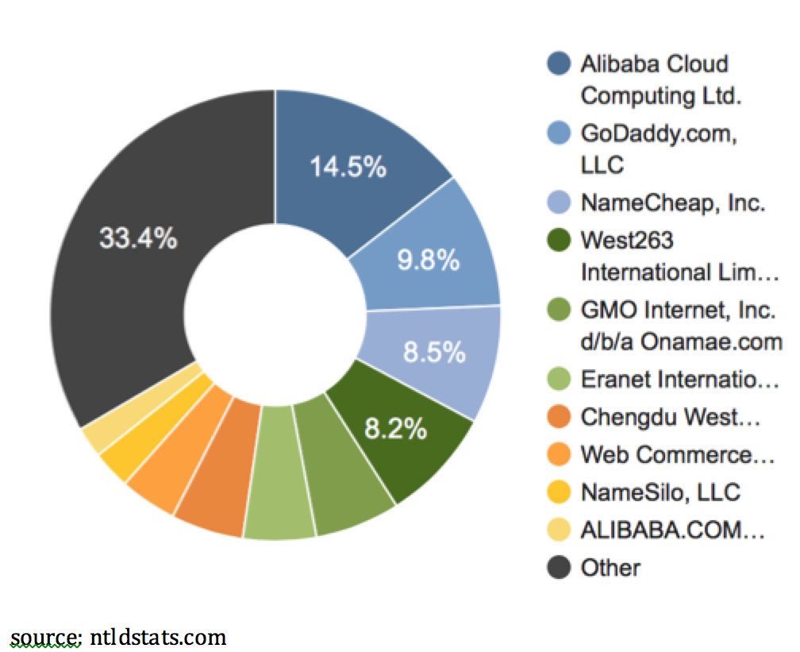In a notable contrast to the monopoly that existed in 1999, Figure 1 demonstrates that the market structure in 2019 models one resembling perfect competition, with many firms that produce the same product present and each possessing a comparatively small fraction of market share (nTLDStates, 2020). Far from possessing a monopoly position, the leading firm Alibaba controls only 14.5% of the domain registration market. Additionally, this notable shift in the composition of the market in only two decades may signal strong factors of competition in online markets.
An additional factor that may function as a general barrier to entry in online markets is the first-mover advantage, which broadly refers to the competitive advantage a firm experiences when it is the first significant entrant into a new market (Varadarajan, Yadav, & Shankar, 2007). Conventionally, the first firm to enter a market is understood to have an advantage over subsequent entrants in three primary aspects: technological leadership, preemption of scarce assets, and switching costs that are inherent in this situation from the perspective of the consumer (Lieberman & Montgomery, 1988). Technological leadership refers to R&D advantages such as proprietary products or processes and experience that a first mover may possess. Preemption of scarce assets refers to the ability of first-mover firms to garner increased information about a market and relevant inputs. Additionally, this aspect of first-mover advantage relates to the strategic barriers to entry a first mover may generate, which occurs when a firm deliberately attempts to deter entry by new firms (Besanko & Braeutigam, 2014). Lastly, switching costs may be presented to consumers in choosing new entrants. However, an analysis of 46 different internet markets found that, absent of positive network externalities or patented innovations, the effect of the first-mover advantage appears minimal (Lieberman, 2002). Porter (2001) goes as far as to state that, in the context of online markets, the first-mover advantage is a “myth.” This characteristic of a weak first-mover advantage may partially derive from the previously discussed reversible network effects of online platforms in addition to the relative nonexistence of switching costs in online markets.
Aggregating the data and literature reviewed in this section, there are indicators that suggest internet markets overall trend towards greater competition in market share distribution due to unique characteristics that weaken barriers to entry, such as low search costs, and enhance product differentiation, such as the sizable capacity for customization in online space. Indeed, regarding the transaction of intangible goods across the internet, Subirana (2000) indicates that intermediates of these transactions experience barriers to entry that are near zero. However, internet markets necessitate further exploration in order to determine whether they tend toward more or less concentrated market structures in general, even if the markets are seemingly more competitive. Haucap and Heimeshoff (2013) suggest that it is impossible to accurately collectively gauge the degree of concentration in all online markets, as various factors affect firm concentrations.
Nevertheless, some tentative conclusions may be formulated regarding an important topic of market structure, the leadership of a firm in the metric of market share. Evans (2017) concluded that competition-enhancing factors in online markets contribute to a fragile leadership of market share for companies providing online products. Additionally, leadership in market share does not also indicate that the positions of these leading online firms are enduring (Haucap & Heimeshoff, 2013). These observations would thereby signal that characteristics of online markets assist in facilitating occurrences where the industry control possessed by a particular leading firm can dissolve, with either another firm taking its place or multiple firms establishing themselves in the market. Additionally, this observation is consistent with the other findings above regarding determinants of market structure online, which collectively indicate that easier market entry and a greater degree of product differentiation are likely inherent in the dynamics of internet markets. Indeed, at a cursory glance, the longitudinal market share trends of various online products provide some indication that leadership in this metric is fragile. As mentioned above, the structure of the market for domain name registration experienced a significant restructuring from a monopoly market to one approximating perfect competition. Additionally, an observation of the composition of browser market share displays a similar occurrence. In 2008, Internet Explorer held a comfortable 70% dominance in market share, which fell to less than 30% in 2013. Google Chrome, the current leader in this category, rose from a market share of 0% to one of over 40% in this same time period (Richter, 2013). Likewise, while Outlook led the market share of email clients at 43% in 2010, the product then suffered a diminution in this metric registering a market share of just 7% in 2018. In the same time span, the current leader in this category, Apple iPhone, experienced a rise from 4% to 29% (Specht, 2018). It is important to note that the above exploration of research indicates that leadership of market share of a particular firm is fragile. This observation is distinct from issuing that internet markets tend towards a market structure composed of non-dominant firms, which has not been demonstrated thoroughly. To illustrate, consider the search engine market. While Yahoo! was the principal search engine of choice in 2000 with a market share of close to 50%, existing as the dominant firm in the market, by 2013 this number had decreased to under 10%. Conversely, Google, the current leader, experienced a market share rise from 0% to over 80% in the same time span (Stoffel, 2013). This example displays that a dominant firm in an internet market can lose its leadership in market share, with the market then becoming even more concentrated in regard to market structure if another dominant firm supplants the incumbent.
Market Structure in the SVoD Market
This section explores the aspects of product differentiation and the number of firms as they relate to the SVoD industry. I identify how certain characteristics discussed above manifest in the SVoD industry and suggest how they affect both product differentiation and the number of firms in this space. A general limitation of this discussion deriving from the lack of previous research is that the magnitude of the effect of the factors discussed is unknown.
Product Differentiation
A feature of vertical product differentiation in the SVoD market is the program availability on each platform in regard to number of movies. Consider a consumer deciding on which SVoD provider to subscribe to. Suppose that this consumer is disinterested in watching series and only desires to have the largest selection of movies available, facilitating the conditions for vertical product differentiation to manifest. This hypothetical consumer would then choose Amazon Prime Video as his SVoD provider, as they dwarf the second-largest SVoD provider in regard to the number of programs available, Netflix. 2019 data indicates that the movie library of Amazon registers around 12.5 thousand titles, with Netflix’s registering 4 thousand (Frankel, 2019).
An additional feature of program-availability-derived vertical product differentiation is the quality of programs available on platforms in regard to recency and, separately, third-party ratings. Consider two one-dimensional, hypothetical consumers similar to the one above who desire to watch the most recent or the highest rated popular programs, respectively.
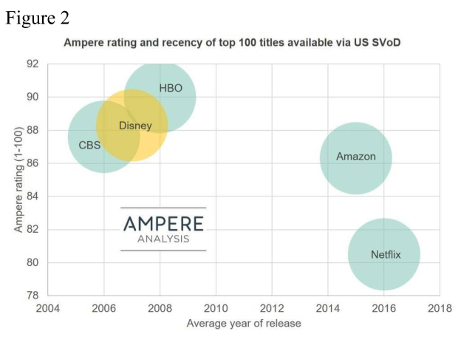 Referencing Figure 2, it is evident that the consumer that derives their utility from recency would choose Netflix given that they have the newest popular titles, while the second would choose HBO Now as they are seeking to consume popular content with the highest average rating. For contextual purposes, Ampere Analysis is a provider-independent content rating firm. Their rating system ranges from 1 to 100 with increasing values progressively denoting a higher quality. While these metrics involving vertical product differentiation can be conjectured to have some effect on the SVoD market as a whole, it is important to note that the magnitude of these features has not been explored.
source: SteamingMediaGlobal.com
Transitioning to factors affecting horizontal product differentiation in the SVoD market, a verifiably significant factor contributing to the degree of this type of differentiation is the availability of exclusive programs on each platform. Data from YouGov indicates that, as of 2017, 43% of SVoD subscribers began using a streaming service to view a specific program. Additionally, data indicate that 23% of Netflix subscribers specifically joined the service for access to Netflix's original programs (Watson, 2015), which are exclusive to the platform. More recently, 2018 data indicates that within the confines of the SVoD market, 71% of global demand for original programs was directed towards Netflix, while Amazon Prime Video and Hulu charted at 11% and 9%, respectively. These data suggest that specific program availability functions to differentiate the SVoD services by consumer preference regarding exclusive shows or movies, thereby increasing product differentiation in this market.
In addition to program availability, horizontal product differentiation can be enhanced by the capacity for customization of user experience afforded by the nature of the SVoD industry. A Morgan (2019) even defines the “Netflix Effect” as “a move towards more convenient, personalized content.” SVoD providers almost ubiquitously house recommendation algorithms that function to alert users to the existence of programs that may pique their interest and thus generate value in regard to utility. These algorithms use a combination of machine learning and artificial intelligence to dole out recommendations (Ladiera, 2019) and are subject to incremental improvements due to the modularity inherent in software as discussed above. Netflix alleges that 80% of the content consumed on the platform derives from these recommendations (Morgan, 2019). Consequent to recommendation algorithms, the experience of each user on a specific SVoD platform is different and product differentiation is enhanced.
Number of Firms
As remarked previously, the counterpart of product differentiation in regard to market structure is the number of firms. A central determinant of the number of firms operating in a market is the strength of the barriers to entry of said market. In addressing the rapid increase of SVoD providers, the Berkeley Economics Review (2019) posits the very low barriers to entry of the industry as the central contributing factor of this occurrence. Of the types of barriers to entry, structural seems the most prominent in the SVoD market.
As previously stated, positive network externalities are a central topic of discussion in regard to demand-derived structural barriers to entry in online markets. Furthermore, there are indications that these network effects are present in the SVoD industry. Haiku and Rothman (2016) identify two manners in which Netflix experiences positive network externalities, which indicate how this phenomenon manifests in the SVoD market in a wider sense. Firstly, the author suggests that network effects in this context arise from the interaction between the number of users and the number of studios that provide content. As the number of users increases, the number of studios that wish to license their content to Netflix in order to expand their audience likewise increases. This occurrence then prompts the number of users to increase, as new users are drawn to the augmented library of content. This interaction facilitates the development of a positive feedback loop. Secondly, the article suggests that Netflix experiences network effects due to the social aspect of viewing content. As more people watch a specific program, the program becomes more popular, prompting more people to watch it. Additionally, with the existence of social media and trends, this popularity may inspire a type of “fear of missing out,” prompting more people to watch a program. Although positive network externalities may be present in the SVoD market, it should be noted that the magnitude of this specific type of barrier to entry has not been thoroughly explored. With Evans (2017) determining that network effects in online space being weaker in general and the Berkeley Economic Review (2019) suggesting barriers to entry in the SVoD market being very low, further exploration may suggest that these network effects are relatively weak.
An additional factor to consider in regard to demand-derived structural barriers to entry is the presence of lock-in effects. As mentioned previously, the low switching costs that are inherent to online products and the low costs of creating an internet platform function to weaken the effects of consumer lock-in in online markets. These features are eminently observable in the SVoD market. The cost of creating an SVoD platform is low compared to the standard startup costs firms experience. The Berkeley Economics Review (2019) expands on this characteristic indicating that an SVoD startup requires only three fundamental and optionally low-cost features: content, servers, and a user interface. Additionally, the switching costs of the SVoD market are virtually nonexistent. Providers do not levy fees for using other services, and there are no hardware requirements specific to an individual provider. Furthermore, subscriptions are often paid on a monthly basis, so consumers are not faced with long-term contracts. As such, consumers can use multiple SVoD providers simultaneously or stop using a provider entirely with no additional cost inherent to either action aside from the subscription fees themselves. Indeed, consumers appear to take advantage of this lack of switching costs, with the average SVoD consumer in the United States subscribing to 3.4 providers (Fitzgerald, 2019). 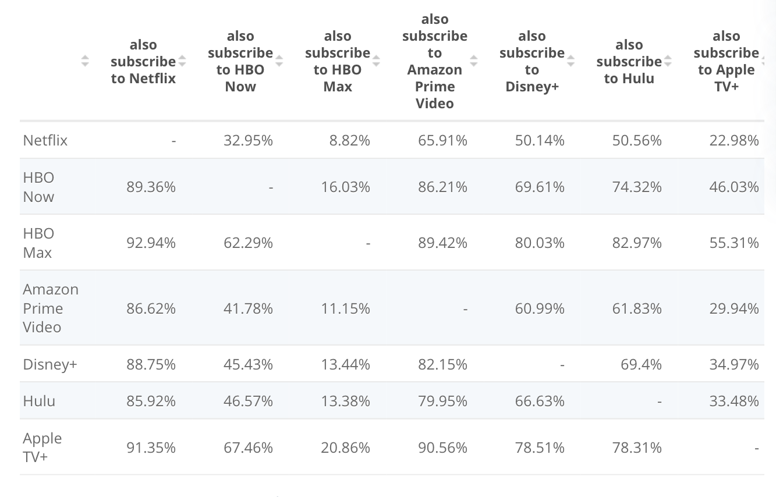
Figure 3
source: statista.com
Referencing Figure 3, there is a remarkable degree of overlap between the subscribers of major SVoD platforms, further illustrating this consequence of low switching costs. The two largest providers, Netflix and Amazon Prime Video, share subscribers at a rate of 65.91% and 86.62%, respectively, a distinctly unique occurrence for any market. Due to these characteristics, it is observable that the lock-in effect of the SVoD market is weak, contributing to overall weaker demand-derived structural barriers to entry.
Lower search costs are an additional consideration in discussing demand-derived structural barriers to entry. Although not explored directly in the context of the SVoD market, low search costs may be assumed inherent through the conclusions of previous analyses of internet markets. Aspiring SVoD customers deliberating over what provider(s) to subscribe to can freely compare the program offerings, price, and ratings of each firm. Additionally, these low search costs may be even further lowered by the aforementioned recommendation algorithms utilized by SVoD providers in that they more efficiently connect consumers to programs that interest them. The significance of this increased efficiency is augmented when in consideration of the fact that an average United States citizen spends 1.3 years of their lives flipping through TV channels in an attempt to find a program suitable to their interests (Rodriquez, 2016). As such, it is observable that the SVoD market has low demand-derived barriers to entry in this regard.
Transitioning from demand-derived structural barriers to entry, cost-derived structural barriers to entry also have some effect in the SVoD market. Economies of scale, a specific cost-derived structural barrier to entry, is observable in the SVoD market primarily through the use of data and the enhanced ability of larger providers to create original content. Firstly, established SVoD firms tend to have relatively greater access to data on their consumers than entrant firms. As a result, these firms can tailor program licensing efforts and recommendation algorithms towards maximizing subscriber count. For example, the popular Netflix original program “House of Cards” was produced using their data on consumer preferences, running these data through algorithms with a combined number of parameters approaching 80,000 in order to predict the viability of the series and the interest it would generate (Guzman, 2017). This example involves the second factor affecting economies of scale in the SVoD market, the capacity to create original content. As seen previously, a significant reason behind subscribing to SVoD services for a selection of consumers is the availability of an original program on a specific platform. The actions of SVoD providers function likewise indicate the importance of original programs. Netflix allocated a notable US $12 billion towards content production in 2018, with Amazon Prime Video and Hulu spending US $5 billion and US $2.5 billion, respectively (Watson, 2020). To contextualize these figures, note that the most expensive movie ever produced, Pirates of the Caribbean: On Stranger Tides, had a budget of US $376.5 million (Acuna, 2020), while the most expensive TV show ever produced, Game of Thrones, spent around US $15 million per episode (Seale, 2019), relatively small fractions of the billions SVoD providers have spent on content. Original programs may also have some influence on economies of scope, as these large-budgeted endeavors may function as quality signals to potential consumers, creating a type of brand recognition. Additionally, an established, large firm such as Netflix may have lower average costs when developing a large number of programs compared to entrant firms attempting to develop similar programs, thus contributing to economies of scope. As such, greater data availability and a relatively enhanced capability to produce original content may exist as beneficial manifestations of economies of scale, which contribute to more rigid barriers to entry.
An additional topic in considering cost-derived barriers to entry in the SVoD market is the relatively easier entrance into the market afforded by the modular nature of internet products. Evans (2017) suggests that this modularity allows firms to branch into other areas of service, functioning to increase competition in online markets. This phenomenon is observable in the SVoD market. Established firms in other areas such as Amazon Prime Video, Apple, and HBO were able to enter the market at a relatively low cost due to the providers’ ability to operate from preexisting technical infrastructure with limited alteration due to the modularity of websites and servers. This characteristic allows such firms to integrate SVoD services into their central platforms at a low cost. For example, an Amazon Prime Video subscriber can access SVoD programs through Amazon’s e-commerce website. This aspect of the SVoD market contributes to low cost-derived structural barriers to entry.
To a lesser degree, legal barriers to entry theoretically manifest in the SVoD market centrally through the licensing of programs. Similar to patents, content licensing may deter entrant firms from the market. A startup SVoD firm may have a more difficult time attracting content providers to its platform. Due to government-enforced intellectual property protection, the entrant firm cannot simply take the product of the content provider. Additionally, content providers may seek to establish their own SVoD service and remove their property from other providers. For example, Disney has been progressively removing content from Netflix in order to create demand for its streaming service, Disney+ (Alexander, 2019). Additionally, up to 20% of all the content on Netflix may eventually be lost to Disney, NBC Universal, and Warner Bros, as the latter companies develop their streaming services (Berkeley Economic Review, 2019). Furthermore, these legal barriers to entry function to augment the value of original and exclusive series on each platform. In this manner, these legal barriers to entry may also encourage product differentiation, as the benefits of a firm deriving from housing original programs necessitate exclusivity, which may prompt greater investment into original content. While the effects of these legal barriers to entry may be conjectured to strengthen barriers to entry, there is no empirical data that would suggest their overall significance.
In regard to understanding the strength of general barriers to entry in the SVoD market, the relative strength of the first-mover advantage is an important factor. As noted, the first-mover advantage in online markets is generally weak. The Berkeley Economic Review (2019) extends this assessment of a weak first-mover advantage to the SVoD market. Traditionally, the first-mover advantage tends to derive from technological leadership, preemption of scarce assets, and switching costs that are inherent in this situation from the perspective of the consumer. In the SVoD market, the lack of complicated technical inputs and ease of establishing the infrastructure from which to operate render the first of these three advantages. Additionally, the inputs required in the production of SVoD content is not subject to physical scarcity, and can always be created by the firm itself, thus eliminating the second of these advantages. Finally, we have seen already that switching costs, the third source of first-mover advantage, are essentially nonexistent in the SVoD market. Collectively, these features suggest that the first-mover advantage in the SVoD market is weak, which assists in contextualizing the trends in market share and market concentration data observable in the next section. More immediately, a weak first-mover advantage contributes to lower overall barriers to entry.
Aggregating the factors that influence both product differentiation and the number of firms operating in the SVoD market, a provisional hypothesis can be constructed regarding the market structure of this industry. In the conclusion of the literature review section, it was determined that online markets cannot be determined to be predominantly more or less concentrated in general using the current body of literature. However, it was suggested that, generally, leadership in the metric of market share in online markets does appear to be fragile, with leading firms subject to being displaced. The SVoD market in particular is characterized by a high degree of product differentiation and overall low barriers to entry. Thus, it follows that leadership in regard to market share is most likely fragile. Furthermore, the lack of factors that demonstrably raise barriers to entry in the market and the overwhelming presence of factors that have been suggested as lowering barriers to entry suggest that the number of firms in the market can readily increase. Consequently, the SVoD market is most likely subject to high competition in market share distribution and a low concentration in market structure.
Methodology
Quantitative Measures of Market Structure
Now that the relevant theoretical factors of market structure in regard to online markets have been outlined, it is necessary to summarize relevant processes and methods conventionally used to determine market structure. Traditionally, market structure is described using two metrics: firm concentration ratios and the Herfindahl-Hirschman Index (Besanko & Braeutigam, 2014). Both metrics can be derived from the market share of firms, where the market share of a specific firm is defined as the proportion of a market accounted for by the firm (Farris, Bendle, Pfeifer, & Reibstein, 2010). N-firm concentration ratios usually determine the proportion of sales deriving from the largest n firms in a market and range from a value of zero to one hundred (Besanko & Braeutigam, 2014). They may also be computed using alternative proxy measures of firm size, such as market share (Besanko & Braeutigam, 2014). Mahajan (2006) indicates that concentration ratios above 40% typically signal the existence of an oligopoly. In regard to the classification of monopolies, in particular, an individual firm will typically possess greater than 70% of the share in a market (The United States Department of Justice, 2015), with a pure monopoly maintaining control of 100% of market share. In addition to concentration ratios, the Herfindahl-Hirschman Index (HHI), which sums the squared market share across the firms in an industry and ranges in value from 0 to 10,000, is used as a descriptor of market structure in that it indicates market share concentration (Besanko & Braeutigam, 2014). The HHI is primarily used when a large number of firms are present in a market and data is available concerning the market share of the top fifty.
Among the metrics used to determine market structure, these two are the most common (Ukav, 2017). In a given market, the number of firms is inversely correlated with the level of market share concentration (Besanko & Braeutigam, 2014). Low HHI and concentration ratio values suggest a less concentrated, more competitive market in regard to market share with more firms, while high HHI and concentration ratio values suggest a more concentrated, less competitive market with fewer firms. These indicators can then be paired with a qualitative assessment of product differentiation in a market to assess the market structure of a particular market. For the purposes of this paper, the n-firm concentration ratio is used as the sole measure of market share concentration due to restrictions regarding data availability and the relatively small number of firms that operate in the market at any given time since its inception.

Measuring the Market Structure of the SVoD Market
The global market share data of the SVoD market required for the purposes of this paper is limited in a few regards. Firstly, no single source provides all of the data. Thus, statistical methodologies in collecting market share data may not be consistent. Additionally, market share data is not directly available for every year of the existence of the SVoD industry. Thus, proxy measures of market share using subscriber-count data are employed to fill necessary gaps in information. Market share in the latter case will be determined using the following calculation: $market share=\frac{global subscriber count of an individual firm}{gross total subscribers of SVoD services for a specific year}$. In the case of market share for 2010, the global SVoD home forecast as opposed to subscriber count is used. However, no proxy measures are available for the years 2009, 2011, 2012, 2014, and 2019. Additionally, the sources used provided market share data on a varying number of firms. In all cases, the greatest number of firms with data for a specific year that could be found are presented. Furthermore, the sample size of the data in regard to the number of years is relatively small, as the industry has only been in existence for a little more than a decade. Also, note that the data for 2025 are projections. To ensure transparency, a detailed description of the source of market share for each year is provided in the appendix.
Data
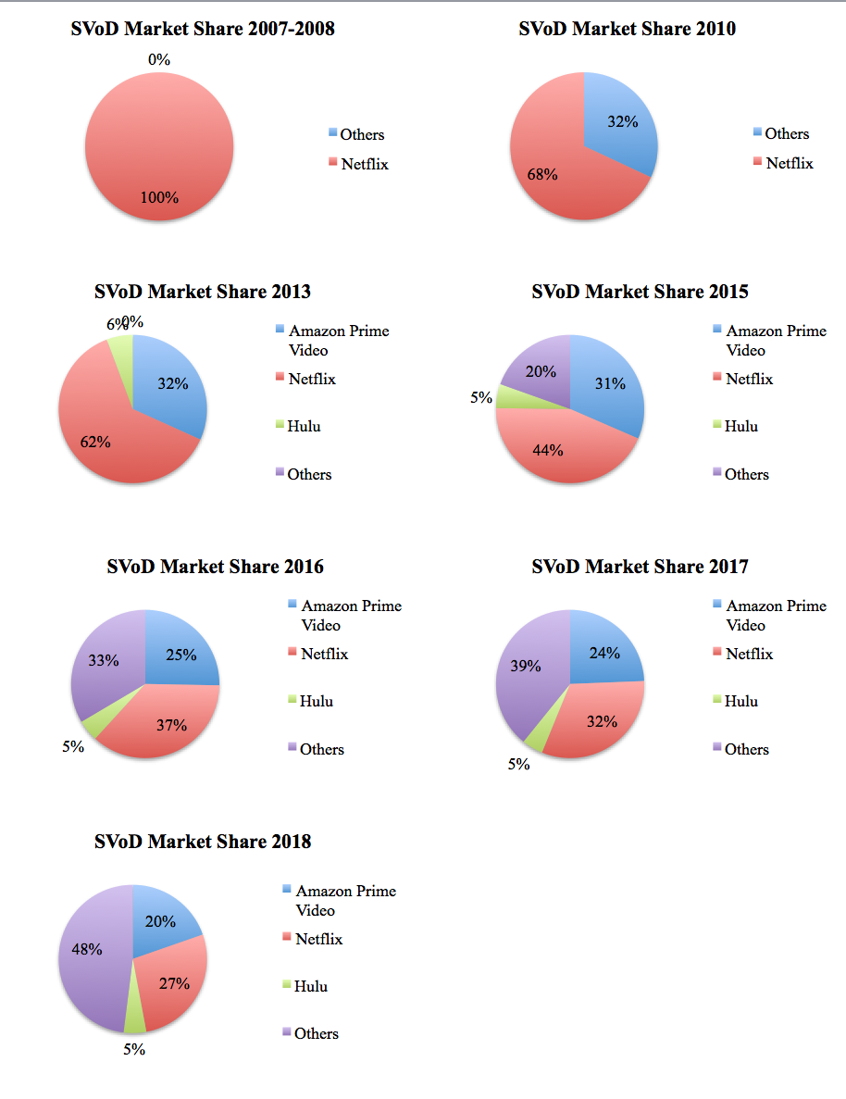
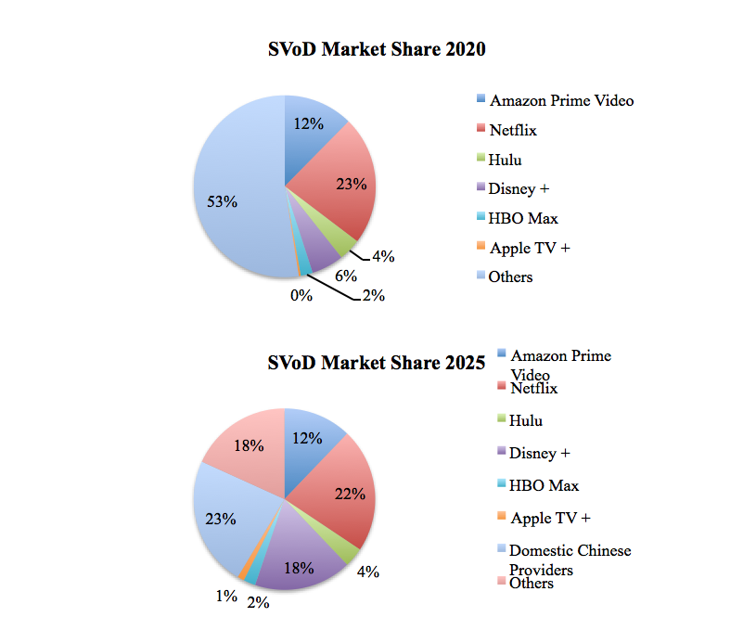
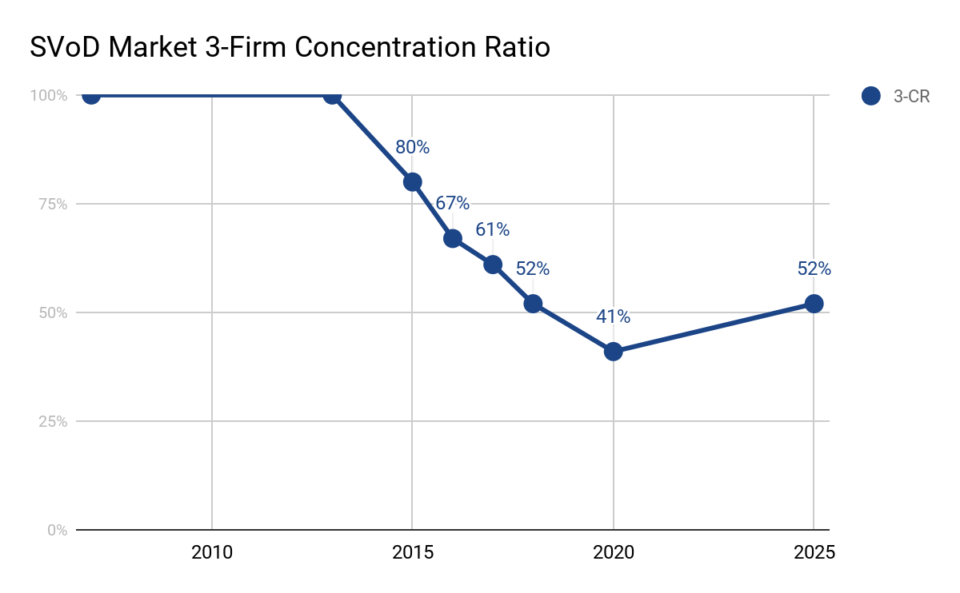
Discussion
In a 13-year period, the SVoD industry underwent various changes in the composition of its market structure. In the creation year of the market, 2007, Netflix held a de facto position of a pure monopoly due to its first-mover status and lack of other entrants. However, Hulu and Amazon Prime Video would then enter the market, altering this structure to a measurable degree. While the concentration ratio of the industry would remain unchanged through 2013, Netflix experienced a precipitous decline in its individual market share from 100% in 2007 to 68% and 62% in 2010 and 2013, respectively. As such, within three years of the creation of the SVoD market by Netflix, the firm transitioned from possessing a pure monopoly to possessing a market share that exists slightly below the standard range of a legal monopoly. Minding the high degree of product differentiation of this market, the market structure of the SVoD industry as a whole transitioned from a monopoly in 2007 to a differentiated product oligopoly in 2013, with a small number of dominant firms producing nonidentical products under the same category. By 2015, other smaller providers began to garner some of the market share previously held by Netflix, Amazon Prime Video, and Hulu, prompting the concentration ratio of the market to fall by 20%. In regard to the concentration ratio, this trend continues up until the point of 2020 data on the market share distribution of the SVoD industry and may continue past this point. The concentration ratio fell from 80% in 2015 to an estimated 41% in 2020. Notably, Disney + displaced Hulu in the consideration of the three largest firms. This decrease in concentration is significant in that it indicates another technical alteration in market structure from a differentiated product oligopoly to one resembling monopolistic competition, with many non-dominant firms producing nonidentical products. As such, this classification is the most accurate when describing the market structure of the SVoD industry in its current state. Additionally, it should be noted that the concentration ratio of the market is projected to increase by 2025, with Disney+ specifically being forecasted to obtain a relatively dominant market share position compared to their current status. However, it should also be noted that the low barriers to entry in this industry may render this projection as one that is subject to change, as new competitors may enter and further disrupt market concentration. Indeed, Disney+ itself functions as an example of this possible occurrence, as they entered the market in late 2019.
These data suggest that the hypothesis constructed regarding market share in the SVoD industry has some degree of validity; leadership in regard to market share is fragile and the market, in general, tends towards greater competition in regard to market share and a less concentrated market structure. In observation of Netflix specifically in the context of market share, their experience substantiates the conclusion of Evans (2017) regarding market share in that the firm suffered a drop in market share of 77% in a 13-year period, suggesting that leadership in the metric of market share while operating on the internet is fragile. Additionally, the diversification of market share distribution that occurred between 2007 and 2020 indicates that the concentration of the market fell significantly, transitioning from a structure of a pure monopoly to one approaching that of perfect competition. Notably, the concentration ratio of the market fell around 60% in this relatively short time period. Thus, the SVoD market does appear to be subject to a high degree of competition in regard to market share and a low concentration in market structure. However, the longer-term forecast in the concentration ratio raises questions regarding the market structure of the SVoD industry, as they suggest that the ratio will begin to rise and exist at a level of 51% in 2025 thus indicating that the market structure may resemble a differentiated products oligopoly. As such, more time and data are needed to establish the true long-term behavior of the market structure in this industry, although these data and the characteristics of the market, in general, suggest that a market structure with low concentration may be the normal state.
Conclusion
The development of market structure in the SVoD industry functions as a case study within the wider topic of how market structure develops in industries that operate predominantly online. Until this point in time, there has been little to no discussion of this particular aspect of the SVoD industry. However, primarily digital industries and products are relatively new phenomena, and there is still much to explore in regard to the market structure SVoD industry and also how market structure develops in online industries in general. Centrally, the findings in this paper contribute to the hypothesis that leadership in the metric of market share in online industries is fragile. Additionally, the paper identified that the distribution of market share in the SVoD industry appears to be widening. However, supplementary research is needed to determine the long-term trend in this characteristic of the industry in light of the relatively recent creation of the market. Furthermore, this paper identified how factors that typically influence market structure manifest in the SVoD industry in particular, although more research is needed to determine the magnitude of these factors in order to determine which have the largest empirical effects on the structure of the market. Furthermore, the consequences of the Covid-19 pandemic are yet to be fully understood in the context of this topic and, likewise to the concentration of the market structure of this industry, will require additional time to pass before insight may be added in this respect. While projections suggest that the pandemic will be a relative boon to the industry due to increased leisure time, the loss of income deriving from the contracted global economy may offset this gain. Notwithstanding this partial lack of information, the expected continued growth of the SVoD industry in both total subscribers and the number of firms presents a promising landscape for future research on this topic.
References
- Acuna, K. (2020, July 02). The 30 most expensive movies ever made. Retrieved from https://www.insider.com/most-expensive-movies-ever-made
- Alexander, J. (2019, October 24). Disney+ downloads will disappear from devices if a title is pulled from the service. Retrieved from https://www.theverge.com/2019/10/24/20930207/disney-plus-downloads-offline-viewing-star-wars-marvel-netflix-bob-iger
- Bar-Isaac, H., Caruana, G., & Cuñat, V. (2012). Search, Design, and Market Structure. The American Economic Review, 102(2), 1140-1160. Retrieved August 15, 2020, from www.jstor.org/stable/23245447
- Berkeley Economics Review Staff. (2019, October 21). The Economics Driving the Streaming Industry. Retrieved from https://econreview.berkeley.edu/the-economics-driving-the-streaming-industry/
- Bernhardt, D., Liu, Q., & Serfes, K. (2007). Product customization. European Economic Review, 51(6), 1396-1422. DOI:10.1016/j.euroecorev.2006.09.002
- Bourreau, M., Dogan, P., & Manant, M. (2007). Modularity and Product Innovation in Digital Markets. Review of Network Economics, 6(2). DOI:10.2202/1446-9022.1116
- Brynjolfsson, E., Y. Hu, and D. Simester. “Goodbye Pareto Principle, Hello Long Tail: The Effect of Search Costs on the Concentration of Product Sales.” Management Science 57.8 (2011): 1373–1386.
- Cassiman, Bruno & Sieber, Sandra. (2002). Impact of the Internet on market structure, The. 10.1142/9789812707628_0015.
- Clement, J. (2020, February 05). Alphabet R&D costs 2019. Retrieved from https://www.statista.com/statistics/507858/alphabet-google-rd-costs/
- Dewan, R., Jing, B., & Seidmann, A. (2003). Product Customization and Price Competition on the Internet. Management Science, 49(8), 1055-1070. DOI:10.1287/mnsc.49.8.1055.16401
- eMarketer. (2020, February 01). US Pay TV vs. Non-Pay-TV Households, 2015-2024 (millions). Retrieved August 26, 2020, from https://www.emarketer.com/chart/233720/us-pay-tv-vs-non-pay-tv-households-2015-2024-millions
- Evans, David S., Economic Analysis of the Impact of the Comcast/Time Warner Cable Transaction on Internet Access to Online Video Distributors (December 23, 2014). Available at SSRN: https://ssrn.com/abstract=2600715 or http://dx.doi.org/10.2139/ssrn.2600715
- Evans, David S. (July 25, 2017). Why the Dynamics of Competition for Online Platforms Leads to Sleepless Nights But Not Sleepy Monopolies. Available at SSRN: https://ssrn.com/abstract=3009438 or http://dx.doi.org/10.2139/ssrn.3009438
- Farrell, Joseph and Klemperer, Paul, Coordination and Lock-In: Competition with Switching Costs and Network Effects (May 2006). Available at SSRN: https://ssrn.com/abstract=917785 or http://dx.doi.org/10.2139/ssrn.917785
- Farris, Paul W.; Neil T. Bendle; Phillip E. Pfeifer; David J. Reibstein (2010). Marketing Metrics: The Definitive Guide to Measuring Marketing Performance. Upper Saddle River, New Jersey: Pearson Education, Inc. ISBN 0137058292.
- Fisher, F. M., & Temin, P. (1973). Returns to Scale in Research and Development: What Does the Schumpeterian Hypothesis Imply? Journal of Political Economy, 81(1), 56-70. DOI:10.1086/260006
- Fitzgerald, T. (2019, March 29). How Many Streaming Video Services Does The Average Person Subscribe To? Retrieved from https://www.forbes.com/sites/tonifitzgerald/2019/03/29/how-many-streaming-video-services-does-the-average-person-subscribe-to/
- Frankel, D. (2019, April 22). Disney+ Will Have One of the Oldest, Smallest SVOD Libraries at Launch: Research Firm. Retrieved from https://www.multichannel.com/news/disney-plus-will-have-one-of-the-smallest-and-oldest-libraries
- Gandal, N. (2001). The dynamics of competition in the internet search engine market.International Journal of Industrial Organization, 19(7), 1103-1117. DOI:10.1016/S0167-7187(01)00065-0
- Gilbert, B. (2020, July 31). HBO Max vs. HBO Go vs. HBO Now: The key differences explained. Retrieved from https://www.businessinsider.com/hbo-go-vs-hbo-now-vs-hbo-max
- Goldfarb, Avi, and Catherine Tucker. 2019. "Digital Economics." Journal of Economic Literature, 57 (1): 3-43. DOI: 10.1257/jel.20171452
- Guzman, S. (2019, September 23). Does Netflix have Economies of Scale? Retrieved August, from https://medium.com/sabrina-guzman/does-netflix-have-economies-of-scale-318c2c273e3e
- Hagiu, A., & Rothman, S. (2016). Network Effects Aren't Enough. Retrieved from https://hbr.org/2016/04/network-effects-arent-enough
- Harvard Business Review. (2017). Netflix: Attracting Both Subscribers and Content Providers to the Party. Retrieved from https://digital.hbs.edu/platform-digit/submission/netflix-attracting-both-subscribers-and-content-providers-to-the-party/
- Haucap, J., & Heimeshoff, U. (2013). Google, Facebook, Amazon, eBay: Is the Internet driving competition or market monopolization? International Economics and Economic Policy, 11(1-2), 49-61. DOI:10.1007/s10368-013-0247-6
- Holcombe, R. G. (2009). Product Differentiation and Economic Progress. The Quarterly Journal of Austrian Economics,17-35.
- Hosch, W. (2020, March 18). Netflix. Retrieved August 26, 2020, from https://www.britannica.com/topic/Netflix-Inc
- Ladeira, J. D. (2019). The algorithm and the flow: Netflix, machine learning and recommendation algorithms. Intexto, (47), 166-184. DOI:10.19132/1807-8583201947.166-184
- Levin, J. (2011). The Economics of Internet Markets. DOI:10.3386/w16852
- Lieberman, M. B., & Montgomery, D. B. (1988). First-mover advantages. Strategic Management Journal, 9(S1), 41-58. DOI:10.1002/smj.4250090706
- Lieberman, Marvin. (2005). Did First-Mover Advantage Survive the Dot-Com Crash?.
- Loginova, O. and Wang, X.H. (2011), Customization with Vertically Differentiated Products. Journal of Economics & Management Strategy, 20: 475-515. DOI:10.1111/j.1530-9134.2011.00295.x
- Mahajan, S. (2004). Concentration ratios for businesses by industry in 2004. United Kingdom Input-Output Analyses.
- Morgan, B. (2019, June 26). What Is The Netflix Effect? Retrieved August 26, 2020, from https://www.forbes.com/sites/blakemorgan/2019/02/19/what-is-the-netflix-effect/
- NoCable. (2020). Cord Cutting Statistics for 2020 - NoCable. NoCable. Retrieved from https://nocable.org/learn/cable-tv-cord-cutting-statistics/
- NTLDStats. (2020, June/July). Retrieved June/July, 2020, from https://ntldstats.com/registrar
- People Are Joining SVOD Services to Watch Specific TV Shows. (2017, October 09). Retrieved from https://www.marketingcharts.com/digital/video-80547
- Porter, M. E. (2001). Strategy and the Internet. Harvard Business Review.
- Richter, F. (2013, September 06). Infographic: 5 Years After Launch, Chrome is on Top of the Browser World. Retrieved from https://www.statista.com/chart/1438/browser-market-share-since-2008/
- Rodriguez, A. (2016, November 07). The average American will waste more than a year over a lifetime looking for something to watch on TV. Retrieved August 30, 2020, from https://qz.com/827726/the-average-american-will-waste-1-3-years-over-a-lifetime-looking-for-something-to-watch-on-tv/
- Samuelson & Nordhaus, Microeconomics, 17th ed. (McGraw-Hill 2001)
- Schmidt, D. (2018). Google Data Collection. Retrieved from https://digitalcontentnext.org/wp-content/uploads/2018/08/DCN-Google-Data-Collection-Paper.pdf
- Seale, J. (2019, November 16). From The Crown to Game of Thrones: What's the most expensive TV show ever? Retrieved from https://www.theguardian.com/tv-and-radio/2019/nov/16/from-the-crown-to-game-of-thrones-whats-the-most-expensive-tv-show-ever
- Smith, E. (2017). Before Netflix: The World's First Streaming Service. Retrieved from https://tedium.co/2017/01/05/first-streaming-service-itv-hong-kong/
- Smith, G. E., Venkatraman, M. P., & Dholakia, R. R. (1999). Diagnosing the search cost effect: Waiting time and the moderating impact of prior category knowledge. Journal of Economic Psychology, 20(3), 285-314. DOI:10.1016/s0167-4870(99)00010-0
- Specht, B. (2018, July 13). Email Client Market Share Trends for the First Half of 2018. Retrieved from https://www.litmus.com/blog/email-client-market-share-trends-first-half-of-2018/
- Statista. (2020). Video Streaming (SVoD) - worldwide: Statista Market Forecast. Retrieved from https://www.statista.com/outlook/206/100/video-streaming--svod-/worldwide
- Stoffel, B. (2013, May 20). Google Stock: Buy It and Hold It For Life. https://www.fool.com/investing/general/2013/05/20/google-stock-buy-it-and-hold-it-for-life.aspx
- Streaming Media Global. (2019). How will Disney stack up against its rivals? Retrieved from http://www.streamingmediaglobal.com/PressRelease/How-will-Disney--stack-up-against-its-rivals_49153.aspx
- Subirana, B. (2000). Zero entry barriers in a computationally complex world: Transaction streams and the complexity of the digital trade of intangible goods. Journal of End User Computing, 12(2), 43-55. doi:http://dx.doi.org.libproxy.lib.unc.edu/10.4018/joeuc.2000040105
- Target Cracks Top 10 US Ecommerce Ranking. (2020, February 28). https://www.emarketer.com/content/target-cracks-top-10-us-ecommerce-ranking
- The United States Department of Justice. (2015, June 25). Competition And Monopoly: Single-Firm Conduct Under Section 2 Of The Sherman Act: Chapter 2. Retrieved from https://www.justice.gov/atr/competition-and-monopoly-single-firm-conduct-under-section-2-sherman-act-chapter-2
- Ukav, I. (2017). Market Structures and Concentration Measuring Techniques. Asian Journal of Agricultural Extension, Economics & Sociology, 19(4), 1-16. DOI:10.9734/ajaees/2017/36066
- Varadarajan, R., Yadav, M.S. & Shankar, V. First-mover advantage in an Internet-enabled market environment: conceptual framework and propositions. J. of the Acad. Mark. Sci. 36, 293–308 (2008). https://doi.org/10.1007/s11747-007-0080-y
- Wasserman, E. (1999, April 21). ICANN to Can NSI's Domain-Name Monopoly. Retrieved from http://edition.cnn.com/TECH/computing/9904/23/icann.idg/index.html
- Watson, A. (2015, September 04). U.S. main reasons for Netflix subscription 2015. Retrieved from https://www.statista.com/statistics/459906/reasons-subscribe-netflix-usa/
- Watson, A. (2020, July 07). Content spend of major SVoD services 2018. Retrieved August, from https://www.statista.com/statistics/1044900/content-spend-streaming-services/
- Watson, A. (2020, July 30). Share of consumers with multiple subscriptions to SVoD services U.S. 2020. Retrieved from https://www.statista.com/statistics/778912/video-streaming-service-multiple-subscriptions/
Data Section References by Year:
- 2010:
  - Ashford, Holly. (2015, November 18). Netflix to reach 115 million subscribers. Retrieved August 27, 2020, from https://www.tvbeurope.com/business/netflix-to-reach-115-million-subscribers
- 2013:
  - Parrot Analytics. (2019, May 5).Global SVOD market share trends based on audience demand for digital originals. Retrieved from https://www.parrotanalytics.com/insights/global-svod-market-share/
  - Watson, A. (2014, October 16). Netflix: Share of the global SVoD market 2013. Retrieved August 27, 2020, from https://www.statista.com/statistics/369231/netflix-svod-revenue/
- 2015-2018:
  - Parrot Analytics. (2019, May 5).Global SVOD market share trends based on audience demand for digital originals. Retrieved from https://www.parrotanalytics.com/insights/global-svod-market-share/
  - Watson, A. (2020, July 16). Number of SVoD subscribers worldwide 2025. Retrieved from https://www.statista.com/statistics/949391/svod-subscribers-world/
- 2020:
  - Research and Markets. (2020, May 14). Global SVOD Market Review and Projections 2010-2025 - Total Subscriptions Will Climb by 170 Million in 2020 due to COVID-19 Lockdown. Retrieved from https://www.prnewswire.com/news-releases/global-svod-market-review-and-projections-2010-2025---total-subscriptions-will-climb-by-170-million-in-2020-due-to-covid-19-lockdown-301059624.html
  - Watson, A. (2020, July 16). Number of SVoD subscribers worldwide 2025. Retrieved from https://www.statista.com/statistics/949391/svod-subscribers-world/
  - Watson, A. (2020, June 10). Hulu: Number of paying subscribers by quarter U.S. 2020. Retrieved from https://www.statista.com/statistics/258014/number-of-hulus-paying-subscribers/
- 2025
  - Easton, J. (2020, March 02). US SVODs to top 300 million subs by 2025. Retrieved August, from https://www.digitaltveurope.com/2020/03/02/us-svods-to-top-300-million-subs-by-2025/
  - Frankel, D. (2020, May 11). Disney Plus and Netflix will Dominate Two-Horse Global SVOD Market in 2025, Research Company Predicts. Retrieved August, from https://www.nexttv.com/news/disney-plus-and-netflix-will-dominate-two-horse-global-svod-market-in-2025-research-company-predicts

Appendix
2007: While no data is directly available for 2007, the constitution of market share is derived from Netflix launching their SVoD service in this year while having no competitors present in the market.
2010: The 2010 market share data is derived from the total global subscribers of Netflix and the gross total global subscribers of SVoD services, with both metrics being provided by Digital TV Research.
2013: The 2013 market share data is derived from the total global subscribers of Netflix, Hulu, and Amazon Prime Video and the gross total global subscribers of SVoD services. The former metrics were provided by Parrot Analytics, and the latter metric was provided by Statista.
2015-2018: The market share data for 2015-2018 is derived from the total global subscribers of Netflix, Hulu, and Amazon Prime Video and the gross total global subscribers of SVoD services. The former metrics were provided by Parrot Analytics, and the latter metric was provided by Statista. Note: The Statista data used for the calculation of market share distribution for this year was different than the data used in the 2013 calculation.
2020: The market share data for 2020 is derived from the projected total global subscribers of Netflix, Amazon Prime Video, HBO Max, Disney +, and Apple TV+. The data concerning Hulu is from its second-quarter subscriber count in 2020. Additionally, the gross total global subscribers of SVoD services. The former metrics were provided by two different Statista graphs, and the latter metric was provided by PR Newswire. Note: HBO Max launched in 2020, replacing HBO NOW while offering the same content with additions (Gilbert, 2020).
2025: The market share data for 2025 is derived from the projected total global subscribers of Netflix, Amazon Prime Video, HBO Max, Disney +, Apple TV+, and the combined share of domestic Chinese providers, all of which were provided by Digital TV Research. Hulu projected subscribers were provided by Statista. Additionally, the gross total global subscribers of SVoD services metric was used, which was also provided by Digital TV Research. Note: the projections for all firms except Hulu are adjusted for the impact of Covid-19.

